AMPLIFYING VOICES FOR NATURE
A campaign to ensure the environment of our region becomes a critical issue in the 2026 Victorian state election
Article 1 of the series
An Ecological Powerhouse — The Bellarine Peninsula and the Geelong Coast
Why the Bellarine and the western shoreline of Port Phillip Bay matter — to Victoria, to Australia, and to the world
About this campaign
This article is part of the Amplifying Voices for Nature project — a campaign to ensure the environment of our region becomes a critical voting issue in the 2026 Victorian state election. The project supports environmental advocacy groups across five key electorates: Polwarth, Geelong, Bellarine, Werribee and Point Cook.
Each article in this series tells a story about what is ecologically significant in this region, what pressures it faces, and what is at stake for the election. We welcome you sharing these articles with your networks.

A Region of Two Stories
There are two ways to describe the stretch of coast running from Melbourne's western suburbs, around the shoreline of Port Phillip Bay, and out along the Bellarine Peninsula to Queenscliff and Ocean Grove.
The first story is about growth. This region has been one of the fastest-growing in Australia for most of the past decade. Greater Geelong alone has been adding around six thousand new residents a year, a growth rate well above the state average, with new suburbs spreading across Armstrong Creek, Lara, Curlewis and Drysdale. Families are arriving every week, drawn by housing that is still more affordable than Melbourne, a connecting rail line, growing employment, and a lifestyle built around the water and the remarkable natural environment in which they now live.
The second story is about what is already here, and has been for tens of thousands of years: one of the most ecologically significant landscapes in Australia. Saltmarsh and seagrass meadows that rank among the most productive ecosystems on Earth. Migratory shorebirds that connect this coastline to Siberia, Alaska, Japan and China. A bay teeming with fish, dolphins and seals, sitting beside a peninsula of remnant woodland, ancient grasslands and globally rare wetlands. This is not just a backdrop to the lifestyle — it is the reason this coast is worth living on.
These two stories are now colliding. And for this region's unique environment to survive the pressure of rapid growth, the people who move here need to understand and value what they have inherited — and the decisions being made, right now, that will determine how much of it remains.
This is the most important area in Victoria — and the sixth most important in all of Australia — for migratory shorebirds.
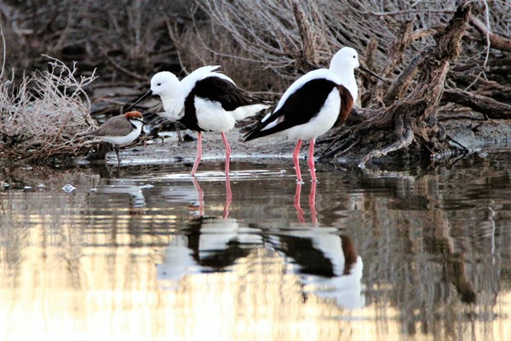
Banded Stilt at the Ramsar wetlands. Photo: Jordan Ayton.
The Existing Bellarine and Geelong Coast Ramsar site — and the case for extension
At the heart of this region sits the Port Phillip Bay (Western Shoreline) and Bellarine Peninsula Ramsar site — one of just sixty-six wetlands in Australia, and over 2,500 worldwide, recognised under the international Ramsar Convention as a Wetland of International Importance. The Australian Government's own assessment describes it plainly: this is the most important area in Victoria, and the sixth most important area in Australia, for migratory wading birds.
What is a Ramsar site?
Ramsar sites are wetlands of international importance listed under the Ramsar Convention. They may be listed because they are representative, rare or unique wetlands, or are important for conserving biological diversity — including waterfowl habitat.
The Ramsar framework was established in Ramsar, Iran, in 1971, and in Australia operates under the Commonwealth Environment Protection and Biodiversity Conservation Act 1999 (EPBC Act). It sets out requirements for management plans and community consultation, and requires that activities which could impact a Ramsar site are assessed.
Importantly, Ramsar listing does not automatically preclude specific activities at a site — rather, it requires that Ramsar sites be managed for sustainable use. Site managers must monitor changes and threats to ecological character, implement management actions to address these, and report any potential change to the relevant government authority.

The site stretches in disjointed pieces from the Point Cook and Cheetham wetlands in Melbourne's west, along the Avalon coast, around to Lake Connewarre south of Geelong, and out to Mud Islands in the bay itself. Altogether it protects more than 22,000 hectares of freshwater wetland, saltmarsh, estuary, tidal mudflat and grassland.
It supports thirteen nationally and internationally listed threatened species — among them the Australasian Bittern, the Fairy Tern, the Curlew Sandpiper, the Eastern Curlew, the Hooded Plover and the extraordinarily rare Orange-bellied Parrot, of which only a handful remain in the wild. It also protects a nationally threatened ecological community found almost nowhere else: Subtropical and Temperate Coastal Saltmarsh.
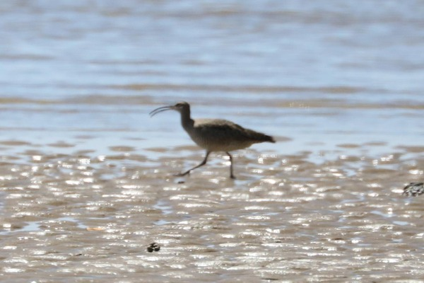
Eastern Curlew on the tidal mudflats. Photo: Jordan Ayton.
Protection above and below the waterline
The Ramsar site protects what lies at the water's edge. Just offshore, a second layer of protection exists for what lies beneath the surface.
The Port Phillip Heads Marine National Park — one of Victoria's most significant marine protected areas — covers the waters around Swan Bay, Mud Islands, Point Lonsdale, Point Nepean, Pope's Eye and Portsea Hole. Here, in The Rip and the waters around it, divers find temperate reefs rivalling tropical destinations for colour and diversity: sponge gardens, kelp forests, weedy sea dragons, Australian fur seals, and dolphins.
Along the shoreline, a chain of marine sanctuaries adds further protection, running all the way from Melbourne's west to the Otways: Jawbone, at Williamstown; Point Cooke, near Altona; Barwon Bluff, at the mouth of the Barwon River near Ocean Grove; Point Danger, between Torquay and Jan Juc; Eagle Rock, at Aireys Inlet; and Marengo Reefs, near Apollo Bay. Each protects a slice of reef and intertidal habitat too small to be a national park on its own, but too important to leave unprotected.
Further along the coast, a second marine national park extends the protection still further. Point Addis Marine National Park runs for ten kilometres of coastline east of Anglesea, protecting dramatic reefs and kelp forests as part of a continuous biodiversity corridor linking through to Eagle Rock and on towards the Otways.
Layer this together and the picture is unmistakable: two marine national parks, six marine sanctuaries, and an internationally significant wetland system, all within a single, fast-growing metropolitan and regional corridor. Few places in Australia combine this scale of formally protected nature with this rate of urban growth happening right beside it.
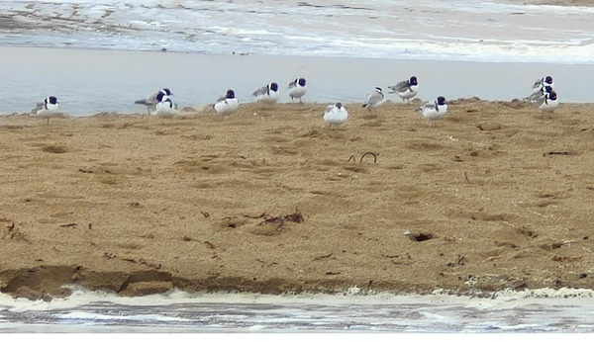
Hooded Plovers on the Bellarine coast. Photo: Ron Hurst.
Development vs Environment — what is happening?
None of this sits in isolation from the growth happening around it. The same population surge that is building new suburbs across the Bellarine and Geelong's growth corridors is placing measurable, documented stress on the very ecosystems that make this region what it is. The examples are not theoretical — they are happening right now.
The Karaaf Saltmarsh
The Karaaf saltmarsh stretches from North Torquay to Breamlea and then towards the Blackrock Wastewater Treatment Plant. One of the most ecologically significant coastal wetlands on the southern Australian coast, it is currently receiving nearly half a gigalitre more stormwater each year than it did before the surrounding area was developed. Half a gigalitre is five hundred million litres. That additional volume carries nutrients, sediment and altered chemistry that encourages invasive reeds and rushes to crowd out the delicate saltmarsh plants, filling in the open mudflats that migratory shorebirds fly thousands of kilometres to reach. The marsh is, in effect, being slowly smothered by the runoff from the suburbs growing up around it.
We will be publishing a full article on the Karaaf Saltmarsh shortly.
The Anglesea River
Further along the coast, the Anglesea River — long regarded as one of the most ecologically intact rivers in the region — is now in serious trouble. The draining of the Lower Eastern View Aquifer to service the demands of the growing population is considered the primary cause. When aquifers that have sustained river baseflows and wetlands for millennia are drawn down faster than they can recharge, rivers lose the groundwater that keeps them flowing between rainfall events. The consequences for fish, macroinvertebrates, vegetation and water quality are severe and potentially irreversible.
We will be publishing a full article on the Anglesea River shortly.
The marine sanctuaries and marine national parks face a different but equally serious pressure.
Recently 70 fisheries compliance officers were removed from Parks Victoria — the officers responsible for enforcing the no-take rules within the very marine sanctuaries and marine national parks described above. The result has been a significant increase in illegal fishing, poaching of crayfish and abalone, and a growing sense among those who use these waters that the rules no longer apply. Protection written into law means nothing if there is no one to enforce it.
The protection of this region's ecological values has been weakened at the advisory level.
The current Victorian Government abolished two independent oversight bodies that provided expert advice on environmental matters: the Victorian Environment and Conservation Council and the Marine and Coastal Board. Both played important roles in ensuring that decisions affecting nature were informed by independent expertise rather than political or development priorities alone. Their removal leaves a significant gap in the accountability structures that are meant to safeguard places like this.
And then there is the Ramsar story.
In 2019, an expert scientific committee led by the Arthur Rylah Institute identified fifteen additional wetland areas that met the international criteria for inclusion in the Port Phillip and Bellarine Peninsula Ramsar site. In 2022, the Project Steering Committee — comprising the land managers and water authorities with direct responsibility for these sites — recommended eleven of those fifteen areas be added. Earlier this year, the Victorian Government recommended just four. Five sites that independent scientists found met the Ramsar criteria were declared not to meet them. The scientific basis for that conclusion has not been publicly explained.
Taken together, these are not isolated incidents. They are a pattern — of protection weakened, enforcement reduced, independent advice removed and scientific findings overridden. For a region of this ecological significance, this pattern matters.
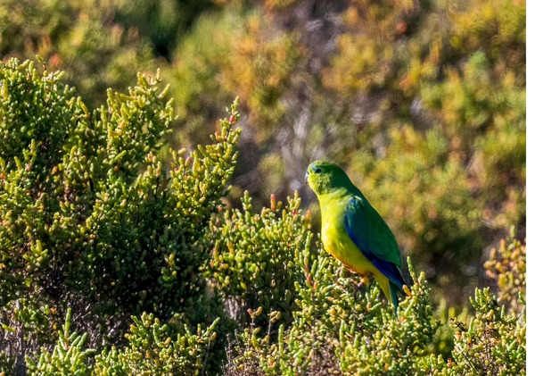
Orange-bellied Parrot — one of the rarest birds in the world. Photo: Ron Shepherd.
A landscape worth fighting for
It would be easy to read this as a story of inevitable loss. We don't believe it has to be. This region's natural assets are still largely intact, still internationally significant, and still capable of thriving alongside a growing population — but only if that growth is managed with the environment genuinely at the table, not treated as an afterthought to be accommodated when convenient.
The people arriving in this region every week deserve to know what they have moved into. They deserve to know that the saltmarsh behind the dunes is internationally significant, that the birds resting on the mudflats in front of them have flown from Siberia, that the reef they snorkel on is protected — and that those protections are only as strong as the political will to maintain them.
Legislation without enforcement is decoration. Science without decision-makers willing to act on it is wasted. And a region as ecologically remarkable as this one cannot afford, in 2026, to be governed as though its natural values are a secondary concern.
Over the coming weeks and months, this series will take you through the detail: the individual wetlands of this Ramsar site and the birds that depend on them; the Ramsar extension decision and how we got here; the rivers and water systems under pressure; the marine environments offshore; and the broader question of what genuine environmental governance looks like. There is much still to fight for. This series is about making sure people know what's at stake.
This is, by any reasonable measure, an ecological powerhouse. It is time it was treated like one.
Article 1 of the Amplifying Voices for Nature series — a campaign to ensure the environment of our region becomes a critical voting issue in the 2026 Victorian state election.
Social Media Versions
Facebook (approx. 110 words):
Facebook: Did you know the stretch of coast from Melbourne's west to the Otways is one of the most ecologically significant places in Australia?
A Ramsar wetland of world importance. Two marine national parks. Six marine sanctuaries. Internationally threatened species. All of it right here — and all of it under real pressure.
Nearly half a gigalitre of extra stormwater every year is smothering the Karaaf saltmarsh. The Anglesea River is in serious trouble. 70 fisheries officers who protected our marine parks have been removed. Two independent environmental advisory boards have been abolished.
We'll be telling these stories — and the stories of what's still worth protecting. 🌊🦅
#AmplifyingVoicesForNature #PortPhillipBay #Bellarine #SurfCoast
Instagram caption:
Instagram: One of the fastest-growing regions in Australia. Also one of the most ecologically important. 🌏
A Ramsar wetland of world significance. Two marine national parks. Six marine sanctuaries.
And right now — half a gigalitre of extra stormwater drowning the Karaaf. A river in serious trouble. 70 marine park officers gone. Two environmental advisory boards abolished.
This is what's at stake. We'll be telling the stories.
#AmplifyingVoicesForNature #Bellarine #PortPhillipBay #SurfCoast #WildVictoria #Ramsar
Newsletter / Website Pull-Box (optional sidebar)
WHAT'S PROTECTED IN OUR REGION
• 1 internationally significant Ramsar wetland site (22,650 ha)
• 2 marine national parks — Port Phillip Heads (Swan Bay, Mud Islands, Point Lonsdale, Point Nepean, Pope's Eye, Portsea Hole) and Point Addis (10 km of coastline east of Anglesea)
• 6 marine sanctuaries — Jawbone, Point Cooke, Barwon Bluff, Point Danger, Eagle Rock, Marengo Reefs
• 13+ nationally and internationally listed threatened species
• The 6th most important site in Australia for migratory shorebirds

